# 

GenSIP Standard Operating Procedures

Cosmochemistry Laboratory - SSL, Berkeley

Contents

Intro 2

How to analyze data from a cleaning test 2

Setting up: 2

Analyzing the dirt loss in the cleaning tests: 3

Examining the Output 4

Analyzing the Molybdenum loss in the cleaning tests: 6

How to Analyze a Large Foil Scan: 7

Setting Up: 7

Make the Mask Image 7

Running Analysis: 8

Running Analysis on the Panorama Images from the SEM 8

Running Analysis on the Sub-Images of a Split-Up Panorama Image: 9

Examining the Output: 9

Notes on performance and problems with the bigscans analysis 9

How to Analyze a Single Image or a Folder of Images: 10

nexus: the jack of all trades in GenSIP 10

Setting Up: 10

Using **nexus.analyzImgOrFolder** 10

Specify the method 11

Running Analysis 12

Troubleshooting: Notes on running analysis on foil pieces: 12

Running Analysis on the Standards 14

Using the histomethod module to analyze by histogram: 14

Appendix I: 15

Persistent problems: 15

Regional Thresholding positives and negatives: 15

Difficulties with pleats, folds, cracks, and holes: 16

Appendix II – The Histogram Method 17

Reading GenSIP Histograms 17

Troubleshooting edge cases with the histogram method 19

Intro

The Genesis SEM Image Processor (GenSIP) module is a suite of tools to analyze the SEM images of the Genesis foils whether they are images of the small cleaning test samples or full scans of the stretched foils themselves. The ultimate goal of this project is to produce reliable, modestly accurate data on the amount of dirt contamination on the foils as well as the amount of molybdenum loss due to flaking, which exposes the platinum substrate. For the large foils, this information will hopefully tell us which portions of the foils are dirty or damaged, and which are clean, and how much dirt needs to be removed. For the cleaning test samples, this information can give us insight into the method of molybdenum loss (dissolution or flaking) and give us an idea of the efficacy of the cleaning processes.

Welcome aboard.

How to analyze data from a cleaning test

Setting up:

1. Scan the sample foils using the SEM before and then after they are cleaned. Make sure that there is enough space between each of the foils so that they can be cropped into separate images on the computer afterwards. Save this image to the Genesis SEM folder on the genesis computer.
2. Using any photo editing software, divide up the before and after images of the foils so that each foil has its own image.

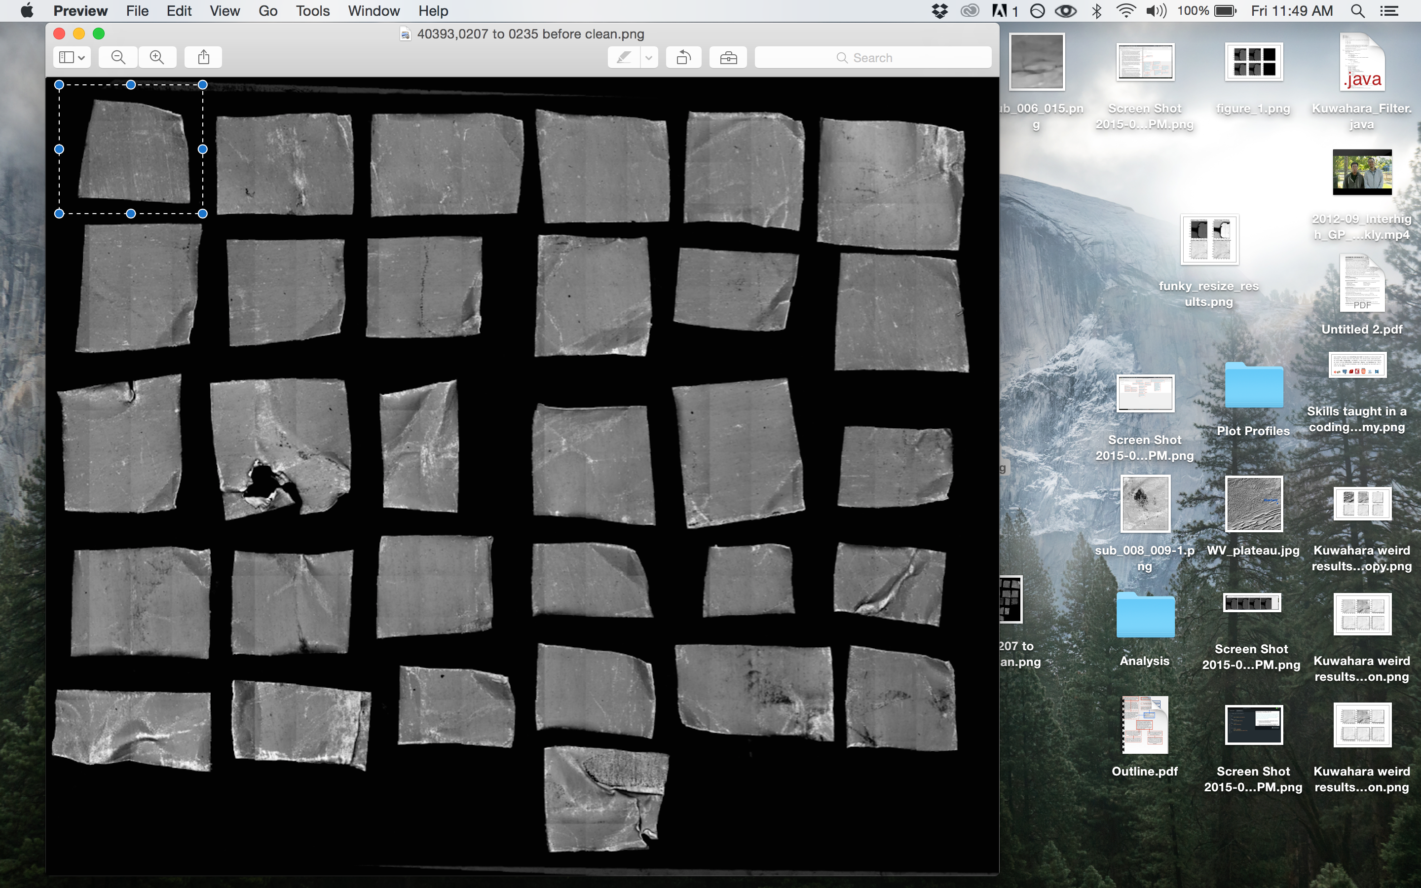

The image name should be of the format “foilnumber before/after clean.extension”. For example: “40393,0208 before clean.tiff” MAKE SURE THAT THE FOILS ARE PROPERLY LABELLED AND ASSIGNED THE ACCURATE FOIL NAME. The program will not be able to accurately compare the before and after images of the foil if the image is of the wrong foil. Also, the program will expect the format, including “after clean” or “before clean” at the end of the foil name.

1. Save the individual images to folders with the title format “Before_SSS” and “After_SSS” where “SSS” is a code corresponding to the cleaning test and set of samples. For example, the folder for the before cleaning images of flight foils for the “BG” test series would be labelled “Before_BGF”. Put these folders into the “InputPicts/Before” and “InputPicts/After” folders within the “GenesisSEMImgProc” folder.
2. Whew! Now you are ready to run the analysis. Breathe a sigh of relief.
3. Open up your favorite Python interpreter. For this example we will use an IPython notebook in Enthought Canopy.
4. Make sure your working directory is set to the “GenesisSEMImgProc” directory. This is how it is done in IPython:

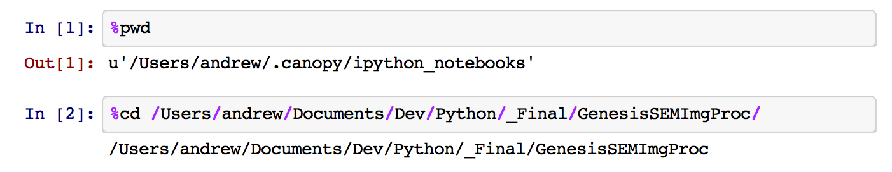

You are now in the proper folder.

Analyzing the dirt loss in the cleaning tests:

1. To analyze the dirt, simply import the dirt module and then run the function analyzeDirt using the sample set string (SSS) and the resolution of the image (pixels per squared microns) as your input:

|  |
| --- |
| import GenSIP.cleantests.dirt as dirt |
| dirt.analyzeDirt(“BGF”,16) |

1. The analyzeDirt function will then produce a set of outputs and store these in a folder “Output_SSS” within the folder “Output.” The outputs are a .csv file labeled “dirt_output_SSS.csv,” which contains the comparison data between the before and after images. The other output is a folder called “DirtMaps” which contains black and white images of the dirt on the foils to show what was detected by analyzeDirt.

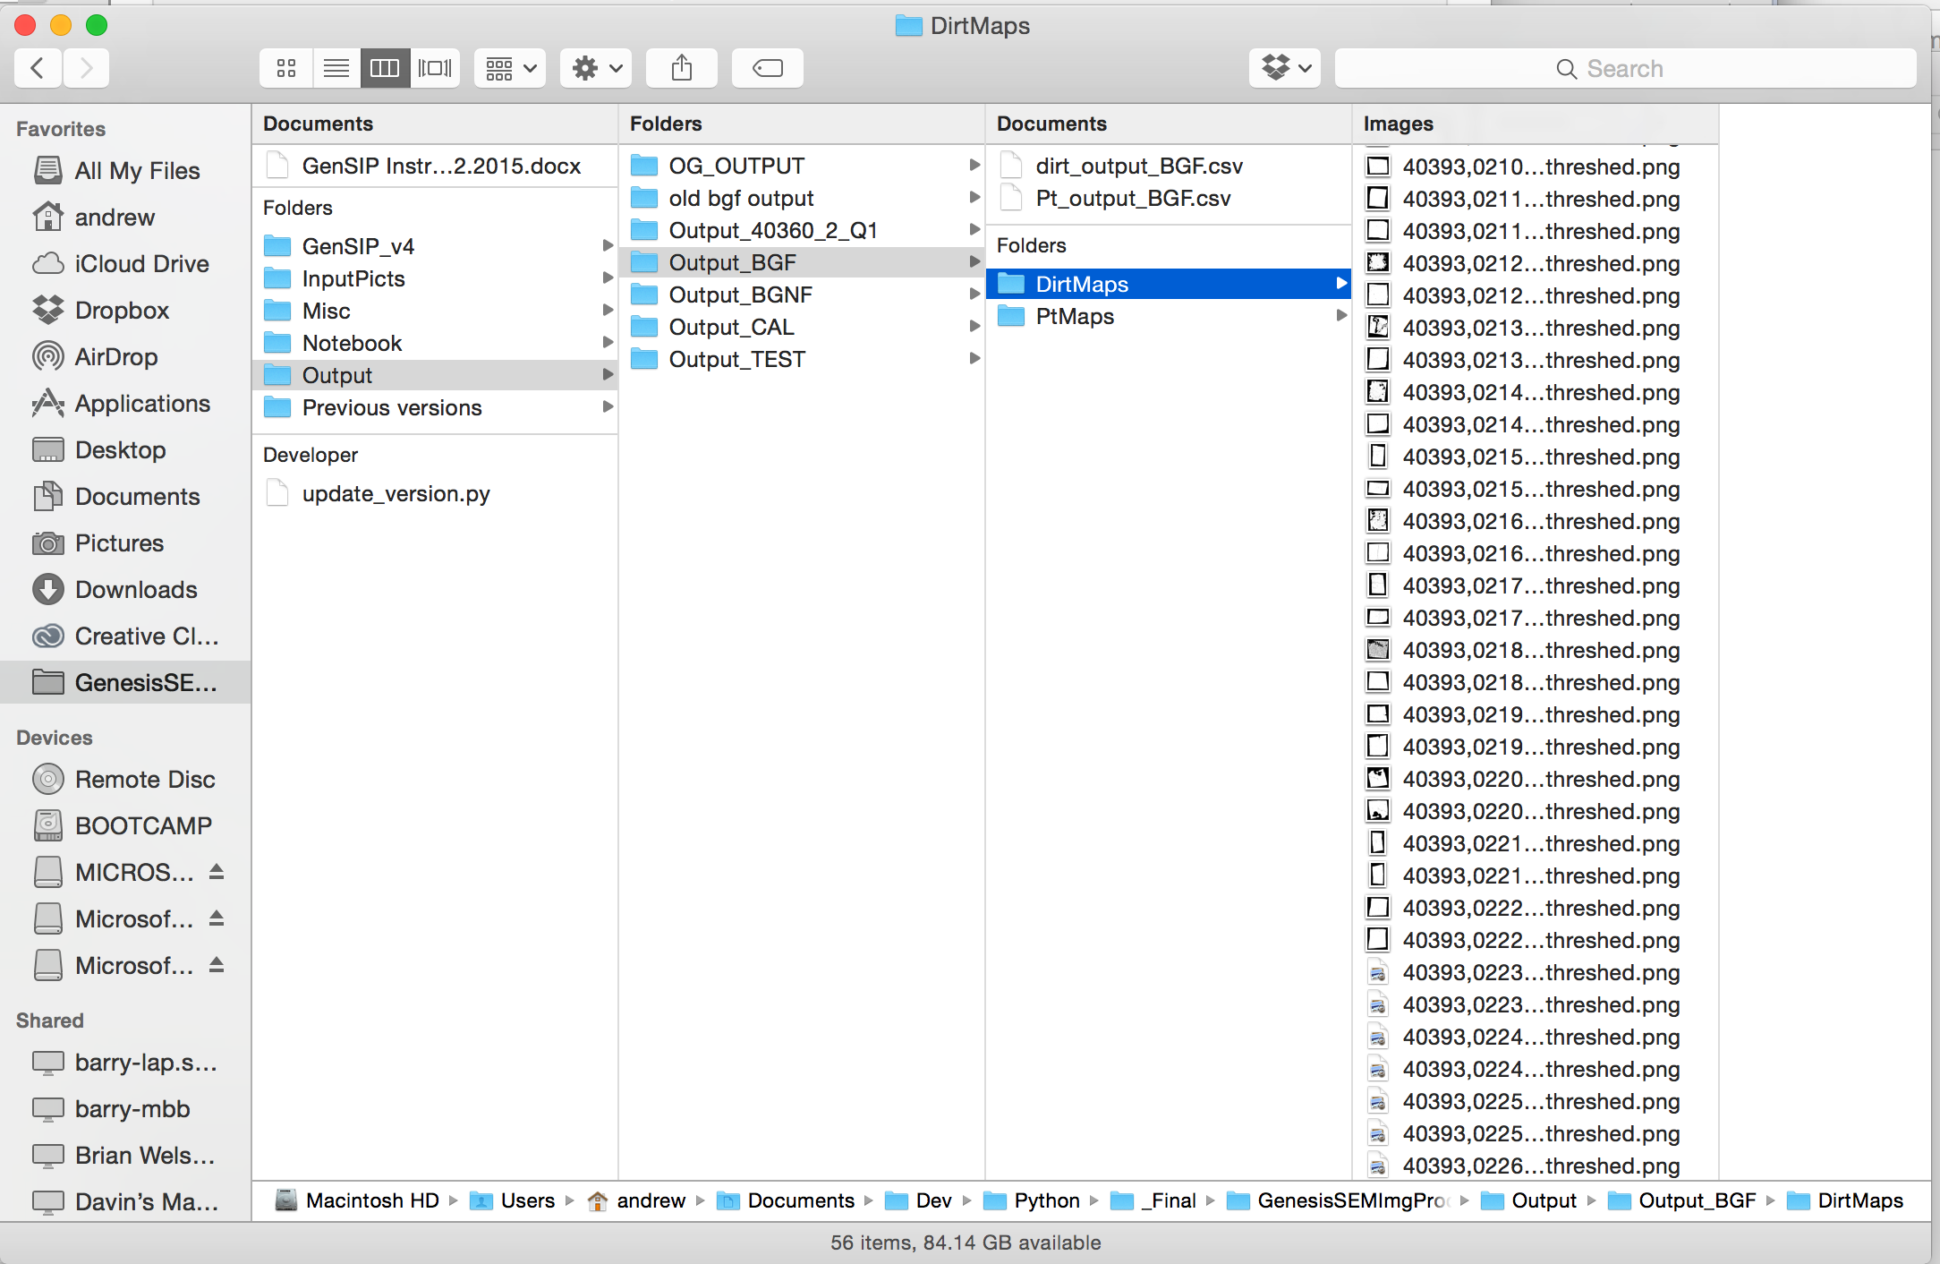

* **Note**: analyzeDirt will also print out some output for errors encountered during processing. If there is a before image but no after image, it will print “No after image for foil <foil number>,” and similarly when there is no before image.

Examining the Output

1. If any of the data in the csv file looks fishy, it is a good idea to go back and look at the DirtMap images of the foils before and after cleaning; you can usually identify a problem with what the algorithm is detecting. For example, one entry in dirt_output_BGF.csv shows a 334.2% increase in the dirt (note that negative values in the ‘dirt loss’ column indicate an increase in dirt):

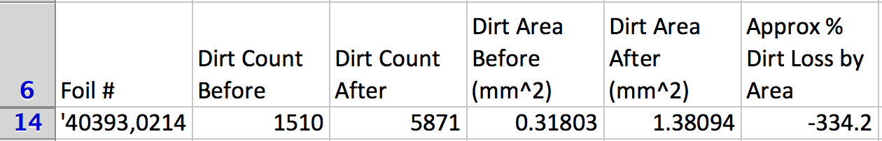

A comparison of the before and after dirt maps shows that something is wrong:

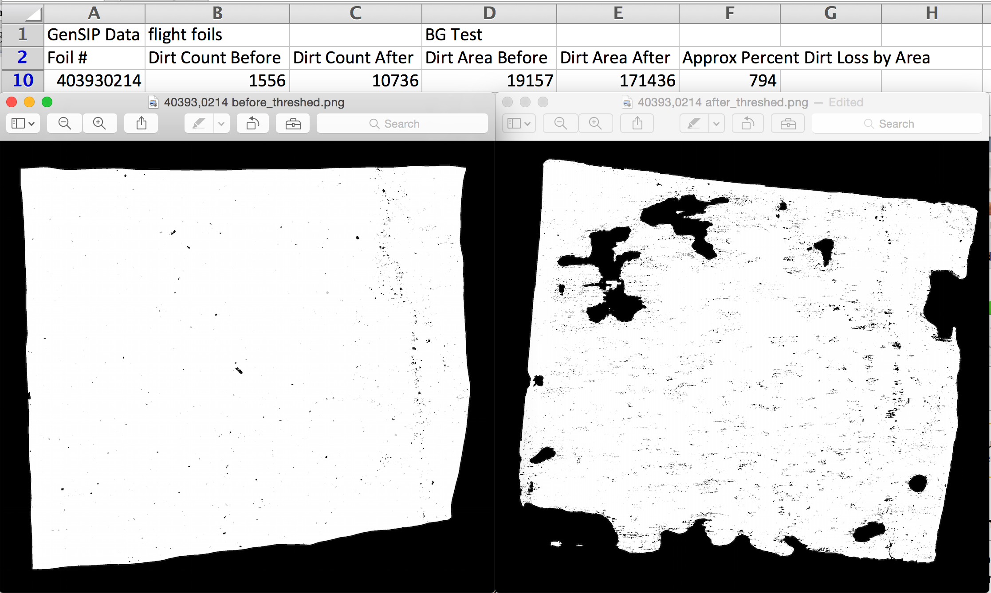

A quick look at the after image of the foil reveals residue left on the foil after the cleaning test:

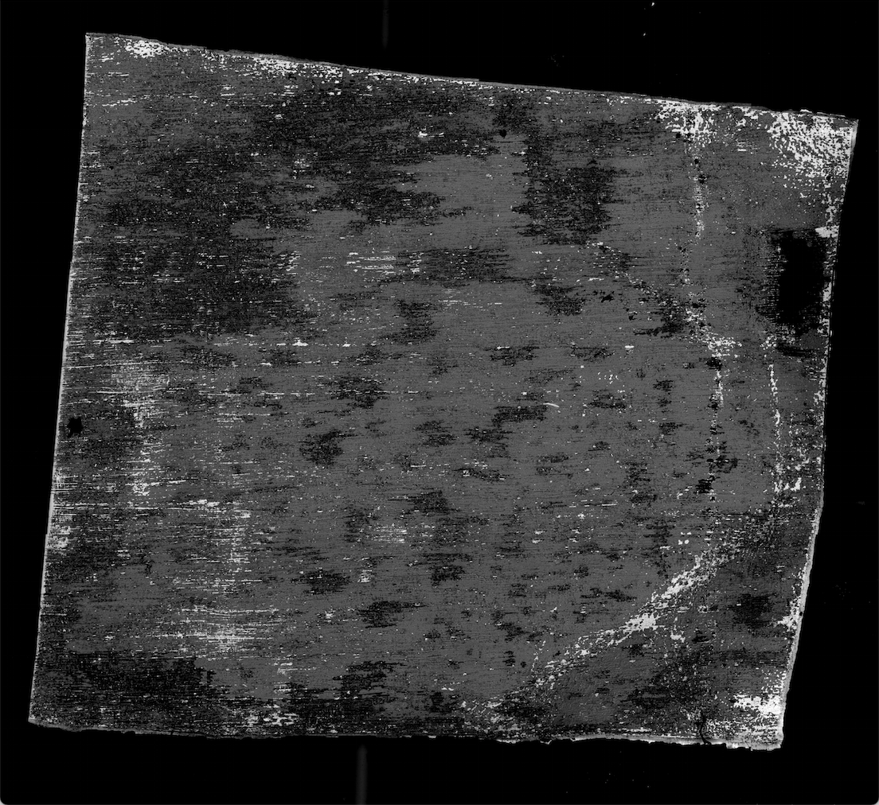

Another example of troubled detection that often arises is when the foil is strangely folded, such as in this case:

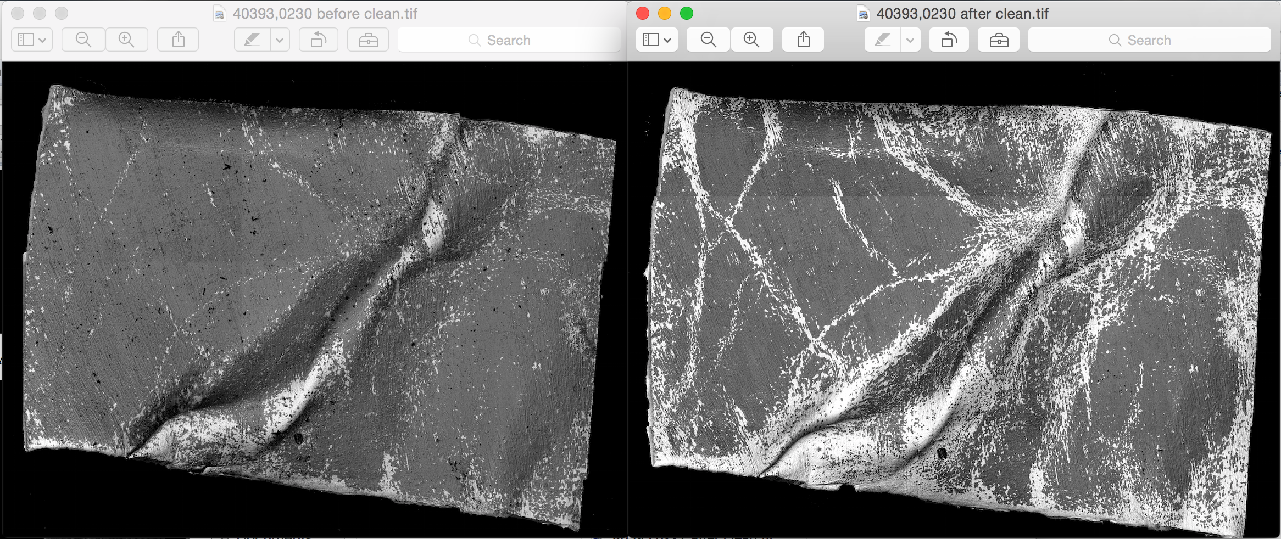

analyzeDirt actually handles this situation pretty well when the surface is uniform, as you can see in the dirtmap of the before image of the foil. However, due to the amount of patchy, exposed platinum in the after image, the algorithm gets confused and counts some of the shadows and foil texture as dirt:

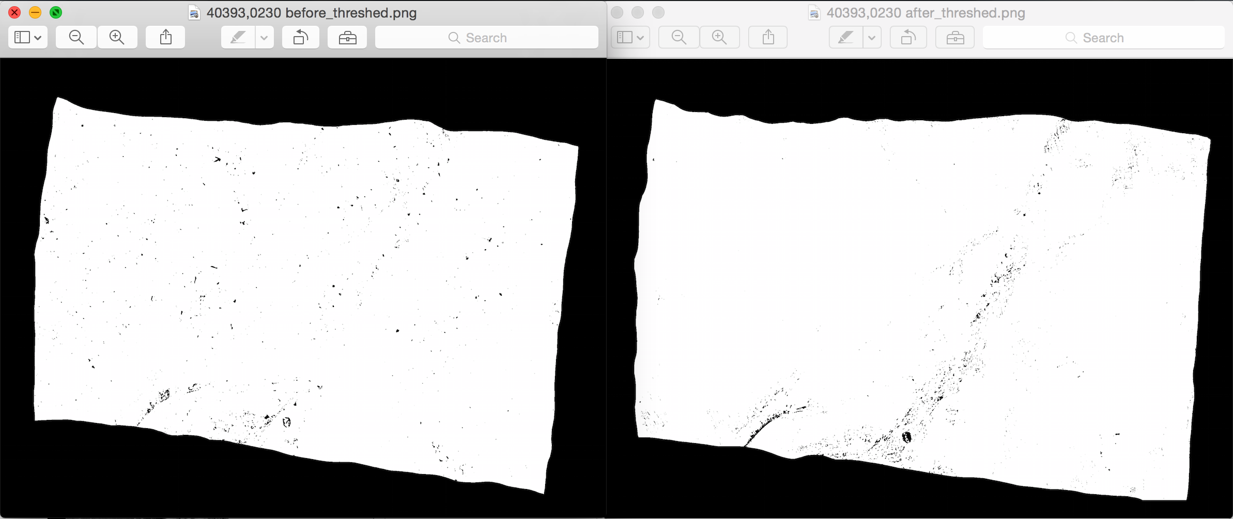

Although by visual inspection of the dirt maps it is evident that dirt was removed from the foil during cleaning, the data does not reflect that:

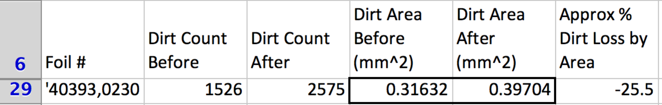

So when the data looks fishy, you can usually find an explanation by looking at the images.

Analyzing the Molybdenum loss in the cleaning tests:

1. Analyzing the Molybdenum loss is pretty much the same process as analyzing the dirt. Simply import the moly module and run analyzeMoly: 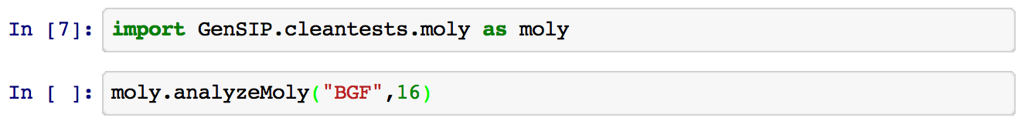

*Examining the Output:*

1. The output is similar: a csv file that provides the molybdenum loss data, and a series of white-on-black images of the exposed platinum on the foils.

*Notes on performance and problems with the molybdenum analysis*

1. For the cleaning tests, the molybdenum loss data is typically more reliable than the dirt data, since it depends on calculating the exposed platinum, which is less affected by topography and texture than calculating the dirt. However, measurements can be disrupted by topographical features that greatly increase the exposure, or by folds, which cause the exposed platinum in that area to have gray levels close to that of the molybdenum. The measurement can also be affected by faulty approximations of the foil area due to weird folds and cuts on the edge of the foil. Again, if you see a fishy piece of data, look at the images.

How to Analyze a Large Foil Scan:

Setting Up:

1. Get the panorama image of the scan that you want to examine. Save it in a folder within the folder “InputPicts/FoilScans.” You do not need all of the small images that were used to make the panorama, only the massive panorama image.

Make the Mask Image

1. I hope to make an algorithm for detecting the cracks and edges of a foil scan, but until that happens, the only way to prevent the cracks in an image from being mistaken as dirt is to manually go through the panorama image and mask them off. Here is how I did it:
   1. Open the panorama image in Photoshop. Make sure it is open as an RGB image.
   2. Go to the channels panel on the lower right and select only the red channel.
   3. Get the eraser tool and erase the entire red channel. Then use the paintbucket tool to paint the red channel black.
   4. Switch to the RGB channel, which selects all of the channels. The image will look funky because the red channel has been erased and blacked out.
   5. Using the paint bucket tool in the RGB channel, color the black area around the foil and all cracks with pure red (255,0,0). Use the pencil tool to fill in areas that are difficult to reach with the paint bucket.
   6. Delete the blue and green channels until you are left with the red channel only. As you delete the channels, the label of the red channel will changes from red to cyan or magenta. Delete until you are left with a black and white, or white and gray image of the mask. The areas you masked off will appear white.
   7. Switch the image type back to grayscale in Image>Mode>Grayscale. Invert the Image so that the areas you masked off appear black and the foil appears white.
   8. Save the image in the folder with the panorama image. Save as a .png or .tif, whichever you choose.

Running Analysis:

Running Analysis on the Panorama Images from the SEM

1. You can analyze both the dirt and the molybdenum on the scans of the stretched foils with the bigfoils module found in the bigscans package within GenSIP. When you first run the analysis, you can use the function analyzePano. This function takes the panorama images of the foil and of the mask you made, and splits them up into a 16x16 grid of sub-images and stores them in two folders within the folder “InputPicts/FoilScans/*Foilname*”. Then analyzePano calls the function analyzeSubImages to run the analysis on the sub-images and produces a set of sub-images of the dirt or exposed platinum in the output folder, as well as a .csv file, just like the analyzeMoly and analyzeDirt functions did for the cleaning tests. Here is an example of how it is done step-by-step:
   1. Import the bigfoils module:



* 1. Define a path string for the panorama images of the SEM scan and the mask that you made:



* 1. Run analyzePano. The arguments are, in order: the path string to the panorama image, the path string to the mask image, the image resolution in square microns/pixel, the foil name, the name of the quarter that was scanned, and the key-word argument MoDirt which specifies whether you want to analyze the molybdenum loss or dirt loss.

In this example we will start by analyzing the molybdenum loss:

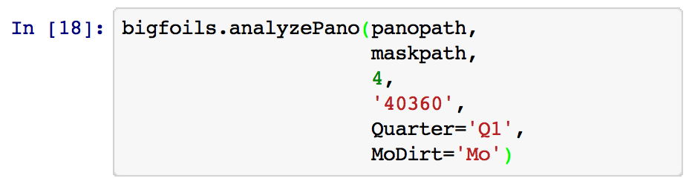

Running Analysis on the Sub-Images of a Split-Up Panorama Image:

1. Once analyzePano has been run, it creates the subimages that are analyzed by analyzeSubImages. If you want to run analysis again, for instance when you want to analyze the dirt after analyzing the molybdenum, then you can just run analyzeSubImages and save some time. The parameters are the same except that instead of providing a path string to the panorama image and the mask image, you provide a path to the folder containing the panorama sub-images and the mask sub-images.
   1. Here is an example of running the dirt analysis using analyzeSubImages:

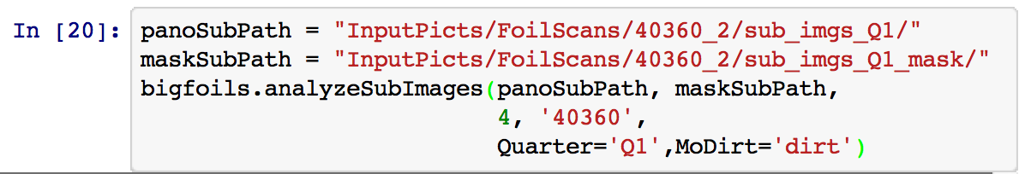

* 1. The resulting output will be found in the folder “Output/Output_40260_Q1”

Examining the Output:

1. analyzeSubImages (and consequently analyzePano) produces as its output a .csv file called “*Quarter*_dirtData.csv” or “*Quarter*_PtData.csv”, and a folder of the dirt maps or exposed platinum maps of the sub images of the panorama. It will also include in that folder an image of the entire foil with the name “montage.png”, which is stitched together from the sub-images. This will allow for the user to quickly spot areas of the foil that were improperly identified (or not identified) as platinum or dirt.

Notes on performance and problems with the bigscans analysis

As things stand now, the tendency is for analyzeSubImages to under-report the amount of dirt and over-report the amount of exposed platinum. This is because the exposure levels of the image vary greatly as the height of the surface of the foil changes. Thus, molybdenum and dirt are lighter at certain parts of the foil, meaning the molybdenum will tend to be counted as platinum, and some of the dirt will be counted as molybdenum. The histomethod module in the currently seeks to address this issue by changing the way GenSIP sets the threshold levels in an image, but until that is resolved this will continue to be an issue.

How to Analyze a Single Image or a Folder of Images:

nexus: the jack of all trades in GenSIP

The module nexus.py was made to bring all the different image analysis methods together under one generic function for analyzing scans called “analyzImgOrFolder.” This is useful for pretty much any application that doesn’t require before-and-after comparison or analysis of a very large panorama image, which are handled by the cleantests and bigfoils packages, respectively.

Setting Up:

1. Place all of the images you want to analyze into a single folder.

Using **nexus.analyzImgOrFolder**

The function nexus.analyzImgOrFolder has the following format:

analyzImgOrFolder (

***Arguments:***

path,

*path to either a single image file or folder of image files*

res,

*resolution of the image in microns squared per pixel area*

***Key-Word Arguments (pre-set):***

method=’cleantests’ , ‘histograms’, ‘bigfoils’ or ‘standard’

*specifies the method to use to analyze the images (see below)*

MoDirt='Mo' *or* ‘dirt’

*option for either molybdenum or dirt analysis*

Mask=0

*Either 0 or a path to a single image or folder of masks*

*(if ‘Mask’ points to a folder, each mask image inside must have the same name as the image it corresponds to)*

genPoster=True *or* False

*function also outputs the poster of the image if set to True*

verbose=True or False

*If set to True, the function will print out more information*

autoMask=True *or* False

*if set to True, the function will seek to automatically mask the background. Not necessary for the ‘cleantests’ method. See below.*

stdDir='standards/'

*path to the directory containing the standards. See the details on the ‘standards’ method below.*

)

Specify the method

With nexus, you specify which method you want to use for your analysis. nexus accepts the following methods (case insensitive):

* “cleantests”, which will use the cleantests.dirt for dirt analysis and cleantests.moly for molybdenum analysis, without having to do the before and after analysis. This method will not be as accurate when analyzing images that are not of individual foils because it automatically creates a border around the edge of the image.
* “bigfoils” uses bigscans.bigfoil analysis without treating the folder as a folder of sub-images. A special key-word argument “autoMaskEdges” allows this method to handle individual foils as well as cleantests does.
* “histogram” is a new method that uses the image histogram to (hopefully) optimize the threshold values for molybdenum and dirt analysis. Similarly to bigfoils, it will only work for individual foil images if the “autoMaskEdges” keyword is set to True.
* “standards” is a special method that calculates the platinum and dirt data for the standard images. The path must be a folder of standards, such as “standards/all_stds/”. The function looks into the folder “standards/” for the folders “all_dirt” or “all_plat”. It then uses those pre-thresholded images to get the platinum or dirt data.

The function will store all output into a folder “Output/Output_<name>_<method>” where name is the name of the folder or image given in the “path” variable. For instance, analyzing the contents of the folder “InputPicts/foobar/” with the “histogram” method will output its data into the folder “Output/Output_foobar_histogram”.

The data is written to a csv file, and the thresholded images are stored in folders “PtMaps/” or “DirtMaps/”. If the key-word argument “genPoster” is set to True, then the posters of the image will be stored in “PosterMaps/”. nexus.analyzImgOrFolder is useful fro comparing methods of analysis, or for just running quick analysis on a batch of images from a recent scan.

Running Analysis

1. Import nexus and define the path to the folder containing all the images you want to analyze. Specify the path to the mask folder if you want to mask the images.

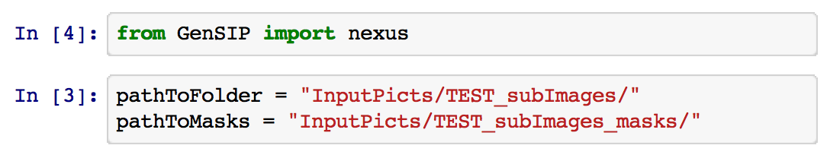

1. Run nexus.analyzImgOrFolder using the path, resolution, MoDirt, and the method you want to analyze the images with.

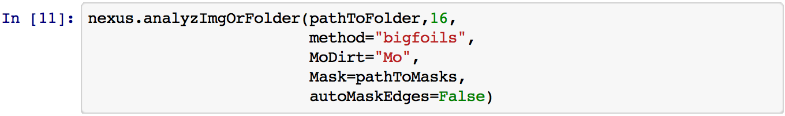

* **Note:** If you are using nexus to analyze a folder of subimages of a panorama, I highly recommend you have a folder of corresponding masks, or else the results will generally be pretty screwy. Also remember that bigfoils and histogram methods are better at analyzing folders of panorama subimages than cleantests.

1. If you want to run analysis on a single image, just specify it with the path and Mask variables.

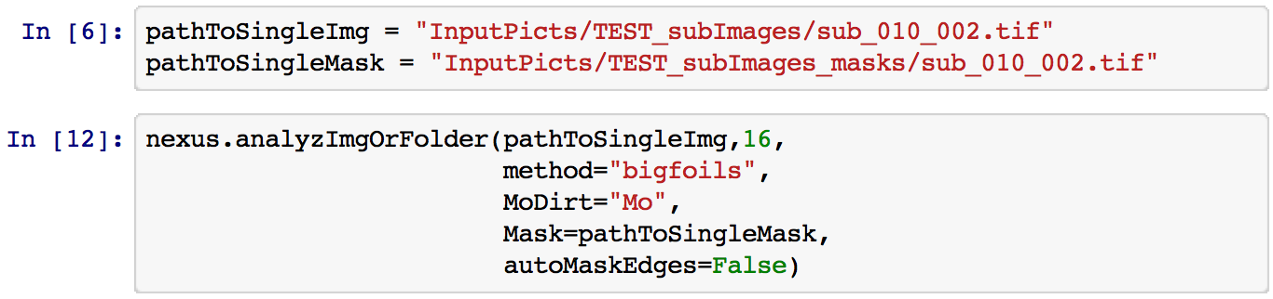

Troubleshooting: Notes on running analysis on foil pieces:

A few problems can come up when you are running analysis on images of individual foil pieces or pieces with a lot of the background showing up in the image, such as below:

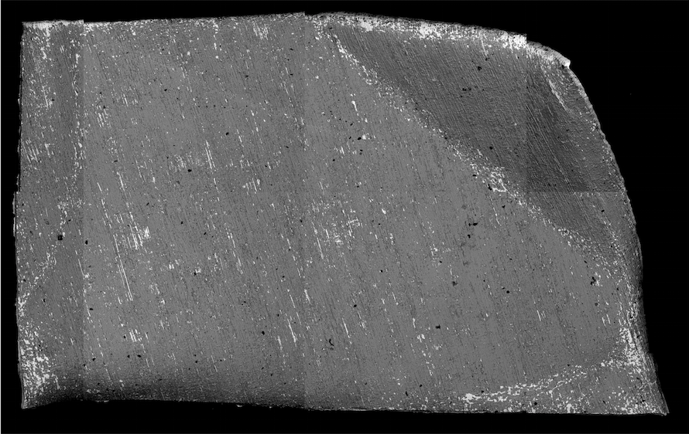

This is mainly a problem for the bigfoils and histogram methods, which would require a mask to remove the background from the calculation.

When you are analyzing one or a folder of images of individual foils, instead of providing a mask you can set autoMaskEdges to True, and analyzImgOrFolder will automatically mask off the background of the image and isolate the foil.

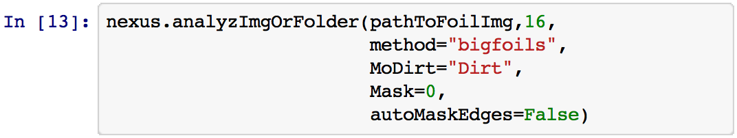

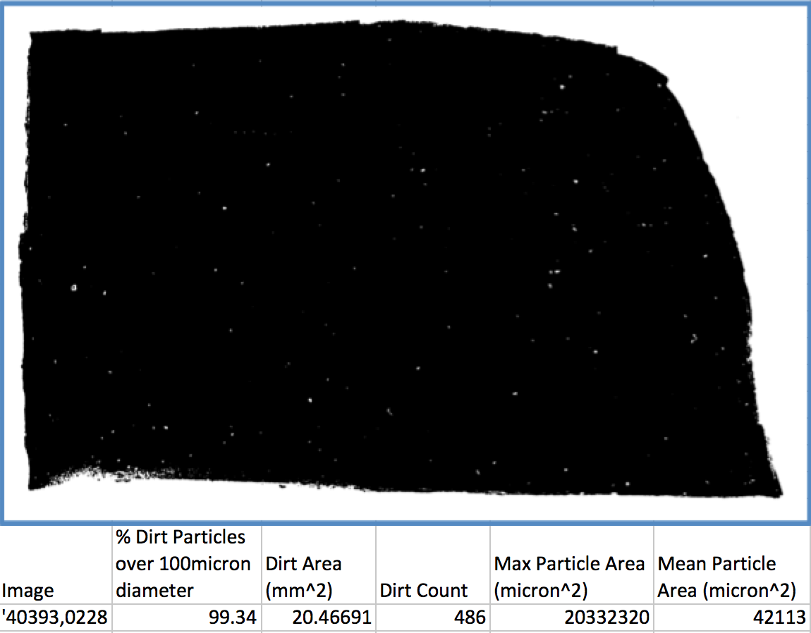

With autoMaskEdges set to False, bigfoils will evaluate the background as dirt, which can be seen in the dirt map image above (the dirt map is white dirt on black background).

Once autoMaskEdges is set to True, only the dirt shows up in the dirt map image (difficult to see but they are there), and the numbers make a lot more sense.

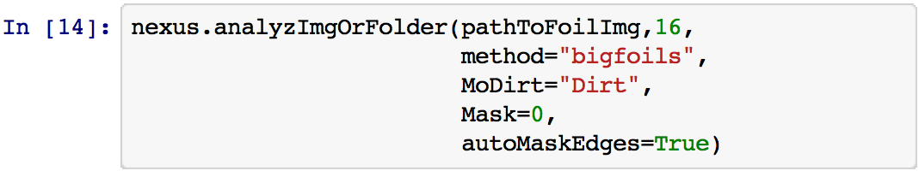

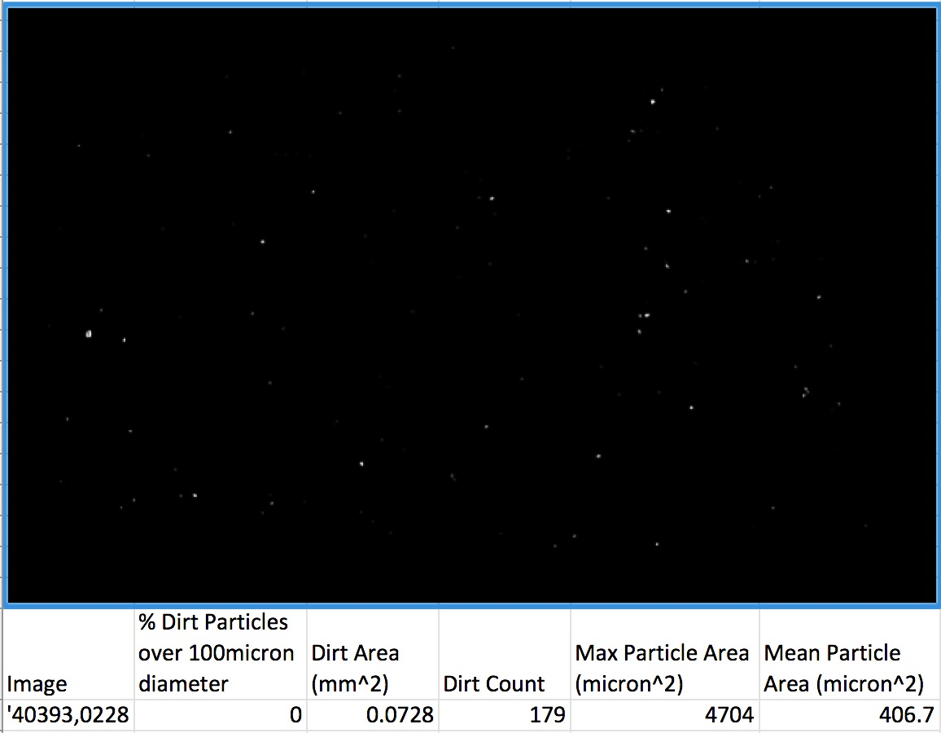

Running Analysis on the Standards

You can create a report of the dirt or molybdenum data of the standard images (which were manually thresholded and processed to isolate dirt and platinum in ImageJ) by running analyzImgOrFolder with the path set to “standards/all_stds” and the method set to standard. This will grab the dirt or platinum threshold images from “standards/all_dirt/” and “standards/all_plat”. You can mask the images by setting mask to “standards/all_masks”.

This procedure is useful when you want to compare the output of a particular method to the “standard” output of these manually thresholded images.

Using the histomethod module to analyze by histogram:

Don’t. Just use nexus.analyzImgOrFolder when you want to use the histogram method.

Appendix I:

Generally, if you run into a problem with one of the analysis methods, you want to first make sure that your path and maskpath are both pointing to the correct directories. The images themselves may cause issues, especially if one of the images is all one shade (all black, or all white), or the mask image does not have the same dimensions as the image itself.

Persistent problems:

Regional Thresholding positives and negatives:

All the methods in GenSIP work by dividing up the image into areas of similar color shades, or *regions*, and applying a particular threshold level to isolate the dirt or platinum in each region. This method has major advantages over just setting one threshold level for the whole image, since not all bright areas of the images are platinum, and not all dark areas are dirt, and the overall brightness or darkness changes due to bends in the foil. However, funky results can occur do to this regional method. If you notice big blobs of black or white on the dirt or platinum maps, you can look up the images poster map, which depicts the different regions colored by up to 5 or 6 different graylevels called “platinum”, “high exposure”, “molybdenum”, ”dark moly”, “pleat”, and “black”. To access the poster for any of the procedures, when you run any analysis method (analyzeDirt, analyzeMoly, analyzImgOrFolder, etc…), set the key-word argument genPoster to True, and the method will put all of the posters it used for analysis in a folder labeled “PosterMaps/” in the output folder.

|  |  |
| --- | --- |
| Macintosh HD:Users:andrew:Desktop:Screen Shot 2015-07-13 at 3.00.00 PM.png 🡪 Macintosh HD:Users:andrew:Desktop:Screen Shot 2015-07-13 at 2.58.13 PM.png | Macintosh HD:Users:andrew:Desktop:Screen Shot 2015-07-13 at 2.59.09 PM.png 🡪 Macintosh HD:Users:andrew:Desktop:Screen Shot 2015-07-13 at 2.56.53 PM.png |
| Examples of images and their corresponding posters | |
|  | |

These issues come up especially with the histogram method, which selects the platinum and dirt threshold levels for each region based on the regions graylevel histogram. If an image is not properly masked, the histogram method will be affected by the background of the image and select a very low platinum threshold level (to a minimum of 100). See Appendix II – Troubleshooting edge cases with the histogram method for examples.

However, this can also be an issue in the bigfoils and cleantests methods, and will again show up as a blotchy pattern on the image. If you want to dig into the code to fix this problem for a particular image, you can change the threshold values (p, d ,m, hE, pt) for each region in the source code. These values are found in the threshImage function in GenSIP/bigscans/ bigfoils.py for the bigfoils method, and in the isolateDirt and isolatePt functions in GenSIP/cleantests/dirt.py and GenSIP/cleantests/moly.py files for the cleantest analysis.

Difficulties with pleats, folds, cracks, and holes:

Inaccuracies may occur also due to the presence of unmasked cracks, holes, and folds (pleats) in the foil. These cause problems especially when analyzing dirt, which will have similar gray levels as the pleats and cracks. Thus, sometimes the dirt data will be very inaccurate. However, you can resolve this by looking at the original image and the dirt image, and then recognize that the problem is clearly due to a surface feature. If you like, you can discard the data for that image, or you can edit the mask in an image editor such as Photoshop or ImageJ, and mask off the problematic feature in black. You may not get data on that feature, but it is most likely going to improve the accuracy overall.

Appendix II – Notes on the Histogram Method

Reading GenSIP Histograms

The histogram method in analyzImgOrFolder outputs a histogram of the different regions of an image to show you a bit of information about how it selected the platinum and dirt threshold levels. Here is a quick rundown of some of the features of those histograms: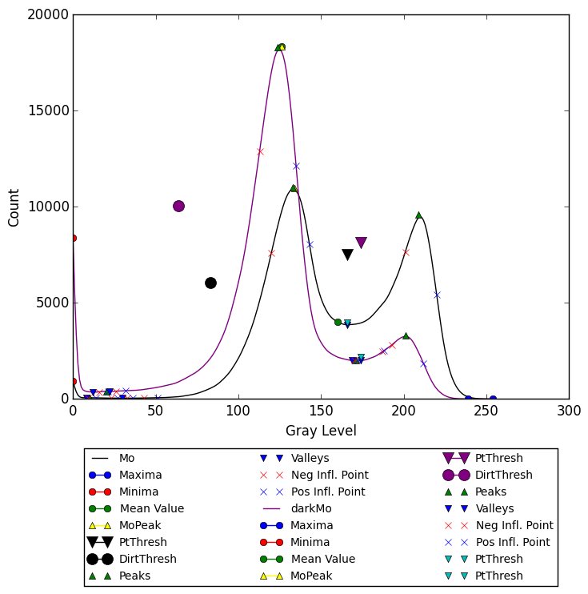

The two plots here represent the histograms for two different regions in this foil image. You will tend to see two peaks in these histograms, one representing the molybdenum and the other representing the platinum. The upside-down triangles represent the platinum threshold values. You can see that the algorithm selected those values as approximately the lowest point in the valley between the platinum and molybdenum peaks. The two large circles represent the dirt threshold levels.

There are many other markers denoting inflection points and peaks and valleys, which were used in the calculation of the threshold values. One marker to note is the small yellow triangle, which indicates the molybdenum peak of the image. This is an important one to watch, since the algorithm uses the molybdenum peak in order to identify the platinum peak and other peaks and valleys. The molybdenum peak is assumed to be the largest peak by count (not necessarily by height), which is why the histogram method has a hard time when the background of an image is not correctly masked off. If the background is not correctly masked off, the background peak could be larger than the molybdenum peak, and then the molybdenum peak will be erroneously identified as the platinum peak, resulting in large areas being identified as platinum, as in below:

|  |  |
| --- | --- |
|  | |
| Histogram of below image when the image is not properly masked. | |
|  |  |
| Original image | Resulting platinum map is clearly off. |

Note that the minimum platinum threshold level for the histogram method is 100.

If you want to make adjustments to the platinum-threshold finding algorithm, it is in the selectPtThresh function in the file GenSIP/histomethod/histogram_tools.py.

Troubleshooting edge cases with the histogram method

For example in an edge case in a panorama image, the background’s dark gray color gets included in the same region as some of the darker regions of the foil, as seen in the image poster:

|  |  |
| --- | --- |
| Macintosh HD:Users:andrew:Desktop:TroubleShooting Poster EX1:Screen Shot 2015-07-13 at 2.11.06 PM.png |  |

This causes a large spike in the histogram around that graylevel, which confuses the selection of the platinum threshold level, and results in areas of the molybdenum being counted as platinum (the “blotchiness” is due to the different regions of the poster):

|  |  |
| --- | --- |
|  |  |

If the image is properly masked, however, the spike disappears and the histogram analysis selects a much more fitting threshold level for platinum:

|  |  |
| --- | --- |
|  |  |
| Mask and poster after image has mask applied to it | |

|  |  |
| --- | --- |
|  |  |
| Histogram and platinum mask when the above mask is applied. | |

If you want to find out what threshold values are being applied to each region, set the key-word argument verbose in any of the analysis methods to True and the method will print out a lot of feedback, including details about what the threshold values are for each region.

The main lesson from this section is: if there is a problem with the platinum or dirt results, especially if the dirt or platinum maps have a blotchy appearance, check the poster to see what the different regions are and see if any features may be causing trouble, then mask them off.